THANK YOU SPONSORS!
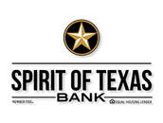
Spirit of Texas Bank

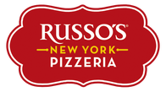
Russo's New York Pizzeria- Conroe

Flexible Lifeline Systems

Chicken Express - Conroe

The Amell Agency

E.S.E We Make Tracks INC

